**MINI PROJECT REPORT**

**on**

**ACCESSORIZE GALORE**

**Submitted as partial fulfillment of**

**MASTER OF COMPUTER APPLICATION**

**DEGREE**

**SESSION 2023-24**

**By**

**Vikash Kumar**

**2200320140192**

**Under the guidance of**

**Megha Saloni**

**Assistant Professior**

**ABES ENGINEERING COLLEGE, GHAZIABAD (032)**



**AFFILIATED TO**

**Dr. A.P.J ABDUL KALAM TECHNICAL UNIVERSITY, UTTAR PRADESH**

**LUCKNOW**

Certificate

I (Vikash kumar ) certify that the Minor Project Report (MCA-169) entitled “**ACCESSORIZE GLORE**” is done by us and it is an authentic work carried out by us at **ABES Engineering** **College**. The matter embodied in this project work has not been submitted earlier for the award of any degree or diploma to the best of my knowledge and belief.

Signature of the Student Date:

Certified that the Project Report (MCA-169) entitled “**ACCESSORIZE GLORE**” done by the above student is completed under my guidance.

Signature of the Guide:

Date :

Name of the Guide :

Designation :

Countersign HOD Countersign Director

Acknowledgement

I sincerely feel that the credit of this project work would not be narrowed down to only one individual. But since analysis phase to construction and development I worked with great perseverance and effort under the guidance of my mentor.

Firstly, I am extremely grateful to ABES Enigneering College, for providing me the excellent working environment to undergo my project.

I have immense pleasure to express my deep sense of gratitude to Mrs Megha Saloni who guided me to do such project in this esteemed institute. For her co-operation and inspiration without which this project studies would not have been possible.

Last but not the least I am thankful to the staffs and management cum administration of my college ABES Enigneering College for helping me in our studies and granting us permission for this project and providing kind co-operation to complete this project.

Finally, I express my sincere thanks to all those who provided me with data information, which was required for this project.

Vikash kumar

# Contents

|  |  |  |
| --- | --- | --- |
| **Sr. No** | **Title** | **Page.No** |
| **1** | **Certificate(s)** | 2 |
| **2** | **Acknowledgment** | **3** |
| **3** | **Synopsis** | **6** |
| **4** | **Chapter 1-Introduction** |  |
| **5** | **Chapter 2- System Requirement Analysis** |  |
| **6** | **Chapter 3- System Feasibility Study** |  |
| **7** | **Chapter 4- System Design** |  |
| **8** | **Chapter 5- System Development (Coding)** |  |
| **9** | **Chapter 6- System Implementation (Screenshots)** |  |
| **10** | **Chapter 7- Testing Methodology** |  |
| **11** | **Chapter 8- Future Scope** |  |
| **12** | **Chapter 9- Conclusion** |  |
| **13** | **Chapter 10- Refrences** |  |

## List Of Tables

|  |  |  |
| --- | --- | --- |
| **Table No.** | **Title** | **Page No.** |
| 1 | Project scope | 10 |

**List Of Figures**

|  |  |  |
| --- | --- | --- |
| **Figure No.** | **Title** | **Page No.** |
| Fig.1 | Agile Model | 8 |
| Fig.2 | Gannt Chart | 17 |
| Fig.3 | Agile Software Development Cycle | 21 |
| Fig.3.1 | Phase Of Agile Workflow | 23 |
| Fig.4 | Use Case Diagram | 27 |
| Fig 4.1 | 0 Level Dfd | 29 |
| Fig 4.2 | 1 Level Dfd | 31 |
| Fig 4.3 | ER Diagram | 32 |
| Fig 5-8 | Home Page | 46-49 |
| Fig 9-10 | Login Module | 50-51 |
| Fig 11-12 | Account Page | 52-53 |
| Fig 13 | Categories Page | 54 |

Synopsis

## Title Of The Project:

ACCESSORIZE GALORE

## Problem Statement:

The current state of our Accessorize Galore platform faces several challenges that hinder its efficiency, user experience, and overall effectiveness. These issues have been identified through user feedback, market analysis, and an internal assessment of our Existing System.

## Description of Proposed System:

Regular updates and improvements to the system will be planned and executed to stay abreast of technological advancements, address emerging challenges, and meet evolving customer expectations.

## Description and Identification of Functional Modules:

1.Admin Module

2.Home Page Module

3.Address Module

4.Registration Module

5.Login Module

6.Profile Module

7.Cart Module

8.Checkout Module

9.Orders Module

10.Reset Password Module

## Tools / Platforms:

#### Hardware Specification:

* + - Operating System : Windows 10,11 or later 32bit or 64bit
    - Processor : Intel(R) Core (TM) i5-10210U CPU @ 1.60GHz 2.11 GHz
    - Memory : 2GB minimum,4GB
    - Recommended Screen Resolution : 1024x680

#### Software Specification:

* + - OPERATING SYSTEM : Windows 11
    - FRONT END : HTML, CSS, JAVASCRIPT
    - BACK END : DJANGO

## Methodology:

* 1. **Agile Model to be Used:**

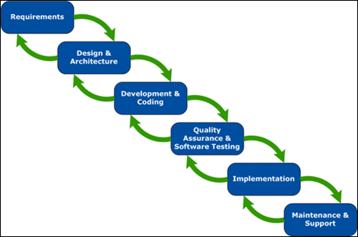

Figure 1

## Justification for the Selection of Model:

The Agile model's flexibility, customer-centric approach, emphasis on collaboration, and adaptability make it a well- suited methodology for the fast-paced and dynamic environment of e-commerce development.

## Project scope

|  |  |
| --- | --- |
| **Project Name** | **Date Revised** |
| ACCESSORIZE GALORE |  |

**Scope Description**

Table 1

This scope provides a foundation for developing a successful

ACCESSORIZE GALORE platform that meets business objectives, user needs, and industry standards. The scope may evolve as the project progresses, and it's crucial to maintain open communication with stakeholders throughout the development lifecycle.

## Future Scope:

The future scope of an E-Commerce project involves considering potential enhancements, expansions, and technological advancements that can be implemented to keep the platform competitive and aligned with evolving industry trends.

# INTRODUCTION

ACCESSORIZE GALORE is a web-based project which is made for remote-shopping or shopping through Internet. As the technology is being advanced the way of life is changing accordance. Now a day’s we can place the order for anything from our home. There is no need to go the shop of the things we want. The order can be placed online through Internet. The payment, the confirmation of purchasing; we can do everything we want. Now we can think that how the days have been changed with time. People had to stand in rows to wait there terms to buy a particular thing from a popular shop.

Welcome to our minor project, an innovative e-commerce web application that revolutionizes the way you shop for exquisite items. In today's fast- paced world, we understand the need for convenience and accessibility, which is why our platform brings a vast collection of stunning products right to your fingertips. With a user-friendly interface and visually captivating design, our web application offers a seamless and immersive shopping experience. Explore our extensive catalog of rings, necklaces, bracelets, earrings, and more, curated from renowned jewellery designers and brands. From timeless classics to the latest trends, our platform caters to every style and occasion. Personalization is key, and our web application provides customization options, allowing you to create your own unique masterpiece by selecting different gemstones, metals, and sizes. Immerse yourself in the world of high-quality imagery, where every intricate detail is captured, ensuring that you can examine each piece up close before making your purchase. With secure payment options and reliable shipping, we aim to provide a hassle-free and delightful experience, making online shopping a joy. Join us on this exciting journey as we redefine the way you discover and acquire exquisite jewelry through our e- commerce web application.

## Problem Introduction

The current state of our e-commerce platform faces several challenges that hinder its efficiency, user experience, and overall effectiveness. These issues have been identified through user feedback, market analysis, and an internal assessment of our existing system. The key problems include:

#### User experience and interface:

* + - * The current user interface lacks intuitiveness and responsiveness Leading to a suboptimal user experience.
      * Navigation through product categories, search functionalities, and checkout and processes is not seamless,resulting in a high bounce rate.

#### Personalization and Recommendation Engine:

* + - * The platform lacks robust personalization features and sophisticated, recommendation engine, limiting our ability to offer personalized product suggestions to users based on their preferences and behaviours.

# 1.2 Objective

The objective of our minor project, an e-commerce web application, is to create a seamless and engaging platform that offers a delightful online shopping experience . Our primary goals include:

* **Accessibility and Convenience:** We aim to make high-quality products accessible to customers worldwide, eliminating geographical limitations and providing the convenience of shopping from the comfort of their homes. Our web application will be available 24/7, allowing users to browse, select, and purchase products at their convenience.
  + **Diverse and Curated Selection:** We strive to offer a diverse range of products, catering to different tastes, styles, and budgets. Through collaborations with renowned jewellery designers and brands, we curate a collection that includes both timeless classics and the latest trends, ensuring there is something for everyone.
  + **Engaging User Experience:** Our web application will focus on providing an immersive and visually appealing user experience. Through high-quality imagery, detailed product descriptions, and user-friendly navigation, we aim to engage and captivate users, encouraging them to explore the collection and make informed purchase decisions.
  + **Secure Transactions and Reliable Shipping:** Ensuring customer trust and satisfaction is paramount. We will prioritize secure payment gateways, encryption protocols, and robust data protection measures to safeguard user information. Additionally, we aim to establish reliable and efficient shipping processes to ensure timely delivery and a seamless post-purchase experience.

# Purpose of Project

# Global Market Reach:

Enable businesses to reach a global audience, breaking down geographical barriers and expanding market reach beyond traditional brick-and-mortar limitations.

#### Increased Sales and Revenue:

#### provide a platform for businesses to showcase and sell their products or services to a wider audience, thereby increasing sales and overall revenue. The purpose of an e-commerce project is to leverage digital technology to create an efficient, convenient, and scalable platform for buying and selling, ultimately contributing business

growth, customer satisfaction and market competitiveness.

* 1. **Description of Proposed System:**

**Continuous improvement and updates:** Regular updates and improvements to the system will be planned and executed to stay abreast of technological advancements, address emerging challenges, and meet evolving customer expectations.

* 1. **GANTT CHART**

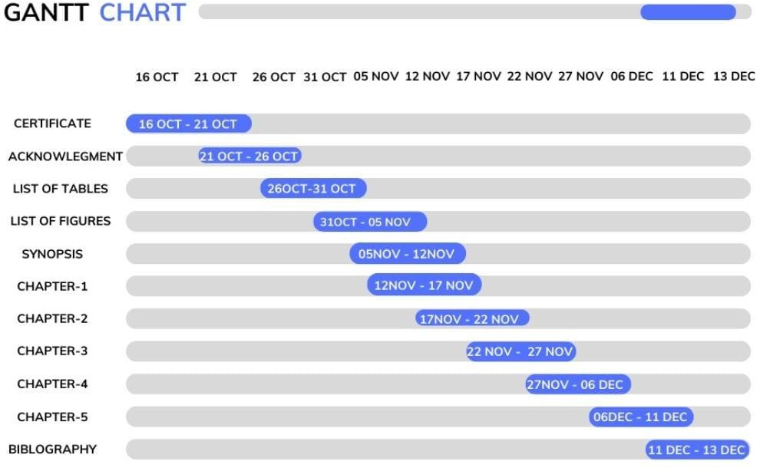

# Figure 2

# SYSTEM REQUIREMENT ANALYSIS

#### TOOLS: SOFTWARE AND HARDWARE REQUIREMENTS

* Python 3.10 (for backend)
* HTML
* Font awesome (for fonts and icons)
* CSS
* Bootstrap (CSS framework)
* JAVASCRIPT
* Sweetify.js (Javascript library)
* Django web framework (python)

#### HARDWARE SPECIFICATION

Operating System: Windows 10,11 or later 32bit or 64bit

Processor: Intel(R) Core (TM) i5-10210U CPU @ 1.60GHz

2.11 GHz

Memory: 2GB minimum,4GB Recommended Screen Resolution: 1024x680

#### SOFTWARE SPECIFICATION

OPERATING SYSTEM : Windows 10

FRONT END : HTML, CSS, JAVASCRIPT

# System Feasibility Study

The Agile SDLC model is characterized by iterative and incremental development, emphasizing flexibility, collaboration, and responsiveness to changing requirements. It involves breaking down the project into smaller, manageable tasks called "sprints" and delivering functional increments at the end of each sprint.

Here are a few reasons why the Agile SDLC model is well-suited for developing an e-commerce jewellery web application:

* Requirements Gathering: Collaborate with stakeholders, such as jewellery designers, customers, and business owners, to gather and prioritize the functional and non-functional requirements of the web application. This involves identifying essential features, customization options, secure payment gateways, and shipping integration.
  + Sprint Planning: Break down the project into small, manageable tasks or sprints, each lasting a few weeks. Define the scope, set objectives, and assign tasks to the development team, ensuring that each sprint delivers a tangible and functional increment of the web application.

Development: Implement the identified features and functionality using an iterative and incremental approach. The development team should work closely with designers and stakeholders, conducting regular meetings to review progress, provide feedback, and make necessary adjustments.

* + Testing: Conduct comprehensive testing during and after each sprint to ensure the quality and reliability of the web application. This includes functional testing, usability testing, security testing, and performance testing to identify and address any bugs or issues promptly.
* Review and Feedback: At the end of each sprint, conduct a sprint review to showcase the completed functionality to stakeholders and gather their feedback. This feedback helps in refining and prioritizing the remaining

features and functionalities for subsequent sprints.

* + Iterative Development and Delivery: Repeat the development, testing, and review cycles iteratively until all the requirements are implemented, and the web application is ready for deployment.
* Deployment and Maintenance: Once all the features are developed and tested, deploy the e-commerce jewellery web application to a production environment. Continuously monitor the application's performance, security, and user feedback to make necessary updates and enhancements in subsequent iterations.

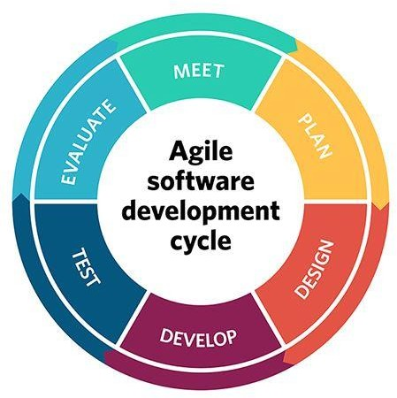

Figure 3

#### Agile Model – Application

* The first phase is dedicated to requirement gathering and analysis. All vital information is gathered and analyzed. This step is designed to resolve all ambiguities regarding future software.
* Design is the second phase of the software development life cycle. This is where the entire architecture of the future project is created.
  + Coding, which is also called implementation, is the third phase in SDLC. All the components of the designed software are implemented, and the source code is created.
  + Testing involves the checking of any faulty parts of the code and their fixes. Everything is thoroughly tested and, if needed, re-tested until all problems are solved.
  + After the software has been tested and all necessary iterations are made, it enters the deployment phase. The project is then released to end users.
  + Maintenance accompanies software along its whole life cycle. If users find any issues, depending on how severe they are, the problem can be hot- fixed or fixed with the next planned release.

#### The Main Phases of Agile Workflow

So, what are the steps in Agile methodology? Just like any other SDLC methodology, Agile SDLC consists of various steps. The main purpose of every step is to bring the team closer to the final result as soon as possible and to new software just as quickly.

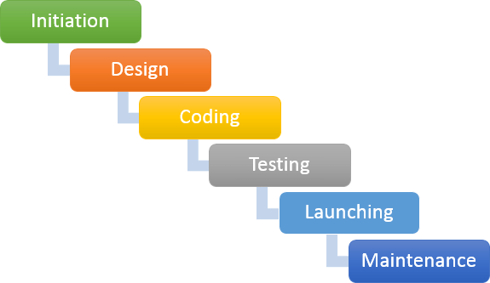

Figure 3.1

#### Typical Agile workflow is comprised of the following steps:

1. Concept – in the first stage of Agile SDLC, the Agile team makes the overall project evaluation, where the team provides business analysis services. This is where the team proves or rejects a hypothesis about business benefit, estimates how much time the project will require, and identifies what resources might be needed later on in development.
2. Inception – after the concept stage comes the phase wherein the laying of a financial foundation occurs and primary team members are identified.
3. Iteration/Construction – during this phase, the team works on delivering working software. It is developed based on iteration requirements and

feedback, and is changed and improved. This phase is divided into multiple timeframes (sprints).

1. Release – this process includes QA testing, user testing, documentation creation, and the release of an iteration into the market.
2. Production – the ongoing software support.
3. Retirement – is the final, and self-explanatory, Agile SDLC phase. Here, the development team stops supporting released software and notifies customers about it.
   1. **MODULES**

This project will have the following modules

* + 1. Admin Module: This module provides administrative functionalities to manage the ecommerce jewelry web application, including user management, product management, order tracking, and generating reports
    2. Home Page Module: It presents the landing page of the web application, showcasing featured products, promotional offers, and navigation options to guide users to different sections of the website.
    3. Address Module: This module allows users to manage their shipping and billing addresses, add new addresses, edit existing ones, and select the desired address during the checkout process.
    4. Registration Module: Users can create new accounts by providing their details, such as name, email, and password, enabling them to access personalized features, save preferences, and track orders.
    5. Login Module: It enables registered users to log into their accounts securely, ensuring authentication and authorization to access personalized features, view order history, and manage their profiles.
    6. Profile Module: Users can update and manage their personal information, including contact details, preferences, and communication settings, enhancing the customization and personalization of their shopping experience.
    7. Cart Module: This module allows users to add products to their shopping cart, view the cart contents, modify quantities, apply discount codes, and proceed to the checkout process
    8. Checkout Module: Users can review their selected products, enter shipping and payment information, choose delivery options, and complete the purchase process securely.
    9. Orders Module: This module enables users to view their order history, track shipment status, and access details of past purchases, ensuring transparency and allowing easy reordering.
    10. Reset Password Module: In case users forget their password, this module facilitates the reset process by sending a password reset link to their registered email address, ensuring account security and accessibility.

# SYSTEM DESIGN

#### Use Case Diagram:

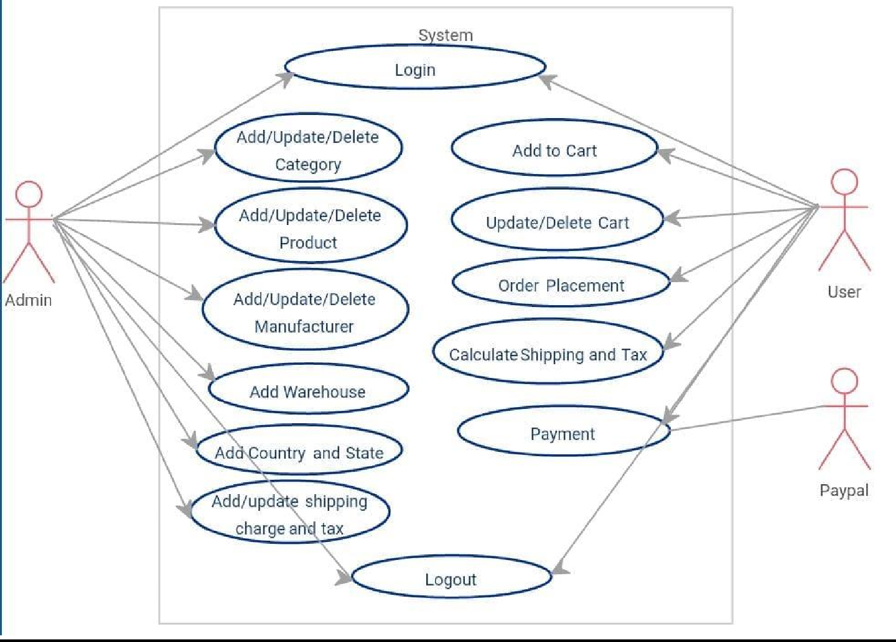

Figure 4

#### DFD (Data flow diagram):

A Data Flow Diagram (DFD) is a graphical representation of the flow of data in a system, and it's used to model the process and information flow in a system. The DFD of Fruit Ninja game would likely include several different levels, showing the flow of data from the player's input, through the game's processing and logic, to the final output, such as the score and game status.

1. **LEVEL DFD:**
   1. Customer: Represents the user interacting with the e-commerce jewelry web application.
   2. Admin: Represents the administrator or staff managing the web Application.
   3. Order Management System: Handles the processing and management of customer orders.
   4. Inventory Management System: Manages the inventory of jewelry Products.
   5. Payment Gateway: Handles secure payment processing.

6.Shipping Service: Manages the shipment and delivery of orders.

7.Customer Support: Provides assistance and support to customers.

8.Database: Stores customer information, product details, order records, and other relevant data.

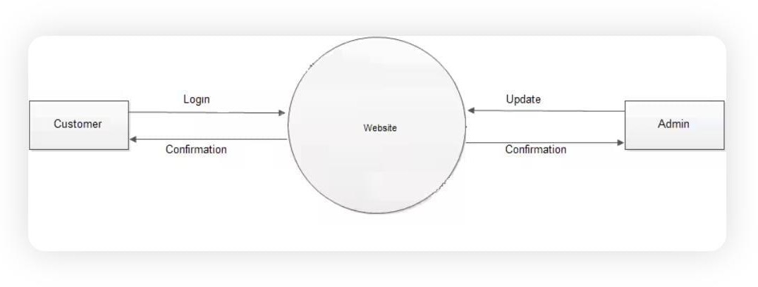

Figure 4.1

### Level 1 DFD (Expanded Processes):

* + 1. Customer Registration: Handles the registration process for new customers.
    2. Browse and Search Products: Allows customers to search and view products based on various criteria.
    3. Add to Cart: Enables customers to add selected items to their shopping cart.
    4. Update Cart: Allows customers to modify the contents of their shopping cart, such as adding or removing items.
    5. Checkout: Handles the process of finalizing the order, including payment, shipping address selection, and order confirmation.
    6. Manage Inventory: Allows the admin to update and manage the inventory of products.
    7. Manage Orders: Enables the admin to manage and process customer orders, including order fulfillment and tracking.
    8. Customer Support: Handles customer inquiries, complaints, and support requests.
    9. Database Management: Manages the storage and retrieval of data in the database, including customer details, product information, and order records.

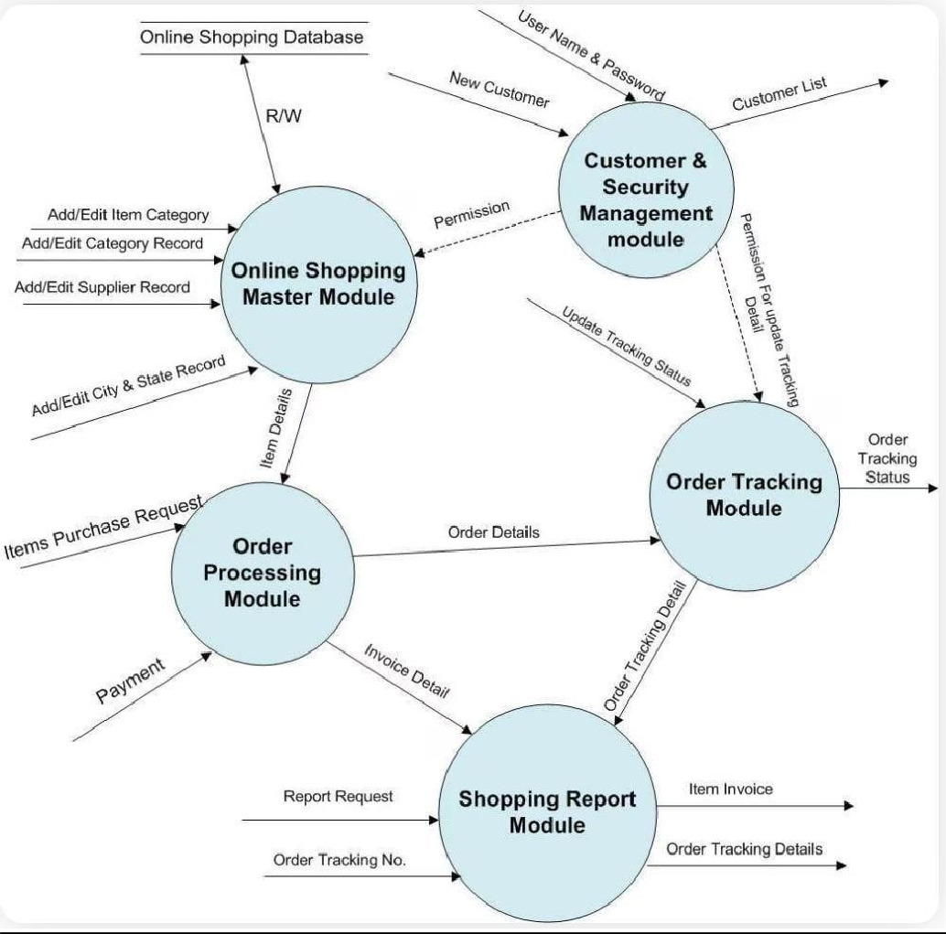

Figure 4.2

#### E-R Digram(Entity-Relationship Diagram)

An Entity-Relationship (ER) diagram is a graphical representation of the entities and their relationships in a database. It is a popular tool used in database design to model the structure of a database and to visualize the relationships between different entities. The ER diagram uses various symbols to represent entities,attributes and relationships.

Figure 4.3

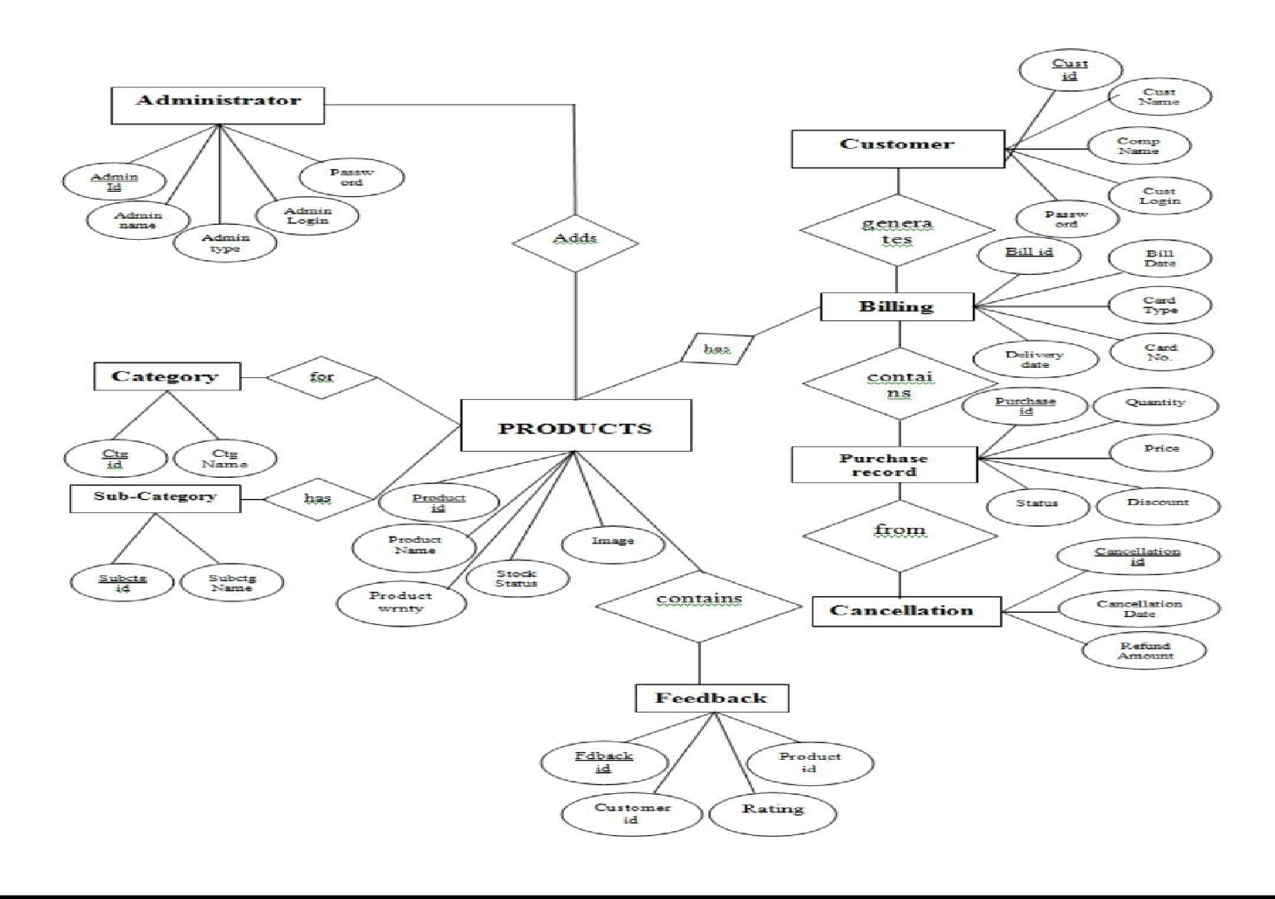

# SYSTEM DEVELOPMENT (CODING)

## HTML

{% extends 'base.html' %}

{% load static %}

{% block content %}

<div class="container py-5">

<div class="col-md-8 offset-2">

<h1 class="mb-5">Log In to Your Account</h1>

<div class="card mb-4" id="forms">

<div class="card-body">

{% include 'partials/_messages.html' %}

<form method="post" action="">

<fieldset>

{% csrf_token %}

{% for fm in form %}

<div class="form-group">

{{fm.label_tag}

{{fm}}

<small class="text-danger">{{fm.errors|striptags}}</small>

</div>

{% endfor %}

<button class="btn btn-primary" type="submit">Login</button>

</fieldset>

{% if form.non_field_errors %}

{% for error in form.non_field_errors %}

<p class="alert alert-danger my-3">

{{error}}

<button type="button" class="close" data-dismiss="alert" aria- label="Close">

<span aria-hidden="true">&times;</span>

</button>

</p>

{% endfor %}

{% endif

</form>

<hr>

Forgot Password? <a href="{% url 'store:password-reset' %}">Reset Now</a> <br> New Member? <a href="{% url 'store:register' %}">Create an Account</a>

</div>

</div>

</div>

{% endblock content %}

**CSS**

text-small {

font-size: 0.85rem !important;

}A

.text-gray {

color: #aaa !important;

}

strong {

font-weight: 700;

}

button:focus, button:active { outline: none;

}

/*

*

* ==========================================

* NAVBAR

* ==========================================

*

*/

.navbar {

position: relative;

}

.navbar .dropdown-menu { border-top: 2px solid #2b90d9;

}

.navbar .dropdown-menu::before { content: '';

display: block;

border-left: 0.5rem solid transparent; border-right: 0.5rem solid transparent; border-bottom: 0.5rem solid #2b90d9; position: absolute;

top: -0.5rem;

left: 1rem;

}

@media (min-width: 992px) {

.navbar-brand { position: absolute; top: 50%;

left: 50%;

-webkit-transform: translate(-50%, -50%);

transform: translate(-50%, -50%);

}

}

.navbar .dropdown-menu { visibility: hidden; opacity: 0;

-webkit-transform: translateY(0.5rem); transform: translateY(0.5rem); transition: .2s ease all;

}

@media (min-width: 992px) {

.navbar .dropdown-menu { display: block;

}

@media (max-width: 991.98px) {

.navbar .dropdown-menu.always-animated { display: block;

}

}

navbar .dropdown-menu.show { display: block;

visibility: visible; opacity: 1;

-webkit-transform: translateY(0px); transform: translateY(0px); transition: .2s ease all;

}

.megamenu { position: static;

}

.megamenu .dropdown-menu { width: 100%;

1. index: 999;

/*

*

* ==========================================

* HERO

* ==========================================

*

*/

.hero {

min-height: 30rem;

}

/*

*

* ==========================================

* CATEGORY

* ==========================================

*

*/

.category-item { display: block; position: relative;

color: #343a40; transition: all 0.3s;

}

.category-item img { transition: all 0.3s;

}

category-item-title { display: inline-block; padding: 0.5rem 1rem; background: #fff;

text-transform: uppercase; letter-spacing: 0.07em; position: absolute;

top: 50%;

left: 50%;

-webkit-transform: translate(-50%, -50%);

transform: translate(-50%, -50%);

box-shadow: 0 0 5px rgba(0, 0, 0, 0.07); font-size: 0.8rem;

}

category-item:hover img { opacity: 0.7;

}

## JAVASCRIPT

[

{

"name": "Afghanistan", "dial_code": "+93",

"code": "AF"

},

{

"name": "Aland Islands", "dial_code": "+358",

"code": "AX"

},

{

"name": "Albania",

"dial_code": "+355",

"code": "AL"

},

{

"name": "Algeria",

"dial_code": "+213",

"code": "DZ"

},

{

"name": "AmericanSamoa", "dial_code": "+1684", "code": "AS"

},

{

"name": "Andorra",

"dial_code": "+376",

"code": "AD"

},

{

"name": "Angola",

"dial_code": "+244",

"code": "AO"

},

{

"name": "Anguilla", "dial_code": "+1264", "code": "AI"

},

{

"name": "Antarctica", "dial_code": "+672",

"code": "AQ"

},

{

"name": "Antigua and Barbuda", "dial_code": "+1268",

"code": "AG"

},

{

"name": "Argentina",

"dial_code": "+54",

"code": "AR"

},

{

"name": "Armenia",

"dial_code": "+374",

"code": "AM"

},

{

"name": "Aruba",

"dial_code": "+297",

"code": "AW"

},

{

"name": "Australia",

"dial_code": "+61",

"code": "AU"

},

{

"name": "Austria",

"dial_code": "+43",

"code": "AT"

},

{

"name": "Azerbaijan", "dial_code": "+994",

"code": "AZ"

},

{

"name": "Bahamas", "dial_code": "+1242", "code": "BS"

},

{

"name": "Bahrain",

"dial_code": "+973",

"code": "BH"

},

{

"name": "Bangladesh", "dial_code": "+880",

"code": "BD"

},

{

"name": "Barbados", "dial_code": "+1246", "code": "BB"

},

{

"name": "Belarus",

"dial_code": "+375",

"code": "BY"

},

{

"name": "Belgium",

"dial_code": "+32",

"code": "BE"

},

{

"name": "Belize",

"dial_code": "+501",

"code": "BZ"

},

{

"name": "Benin",

"dial_code": "+229",

"code": "BJ"

},

{

"name": "Bermuda", "dial_code": "+1441", "code": "BM"

},

{

"name": "Bhutan",

"dial_code": "+975",

"code": "BT"

},

## SYSTEM IMPLEMENTATION (SCREENSHOTS)

**Home page**

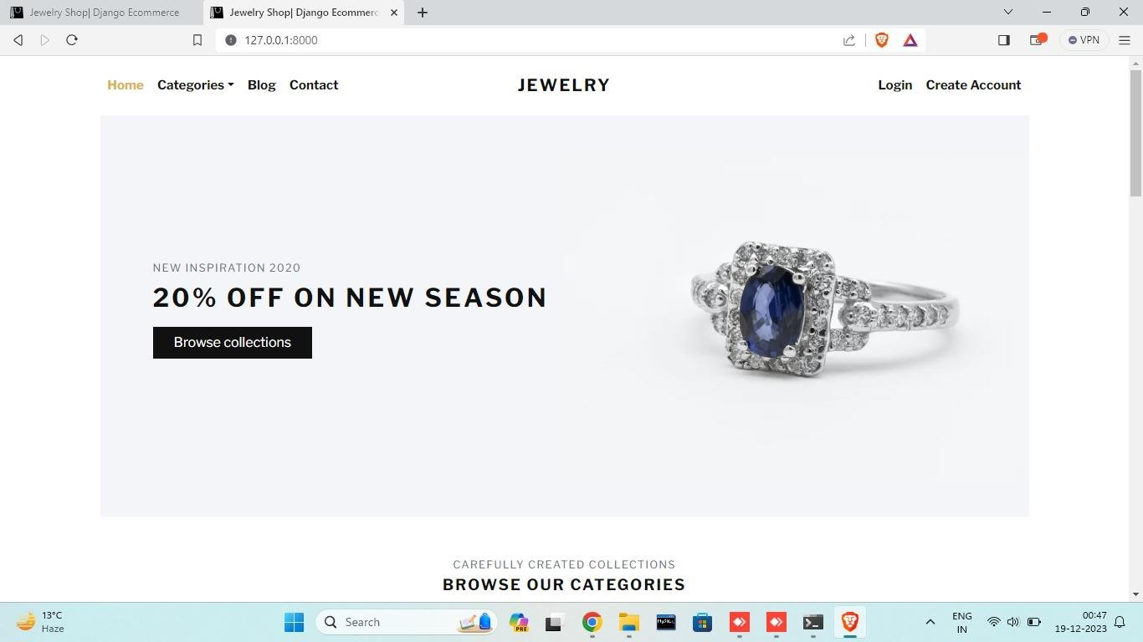

Figure 5

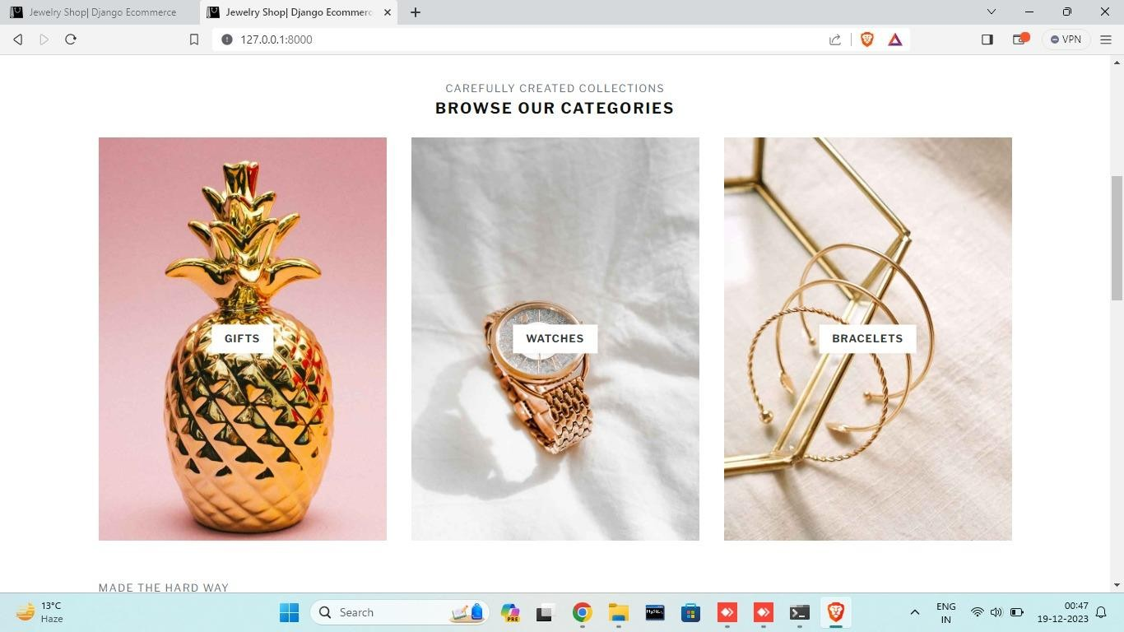

Figure 6

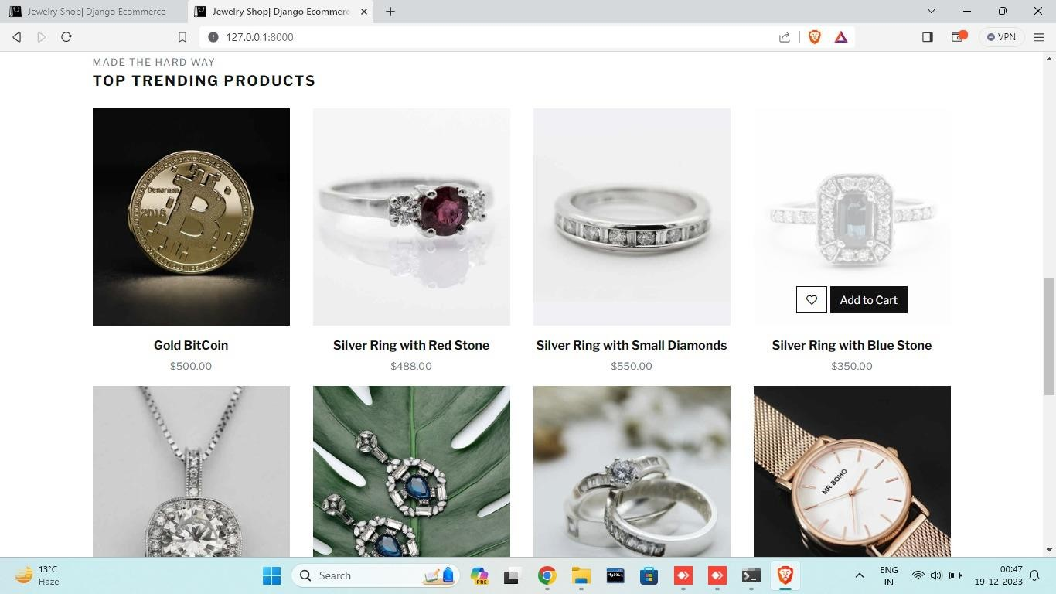

Figure 7

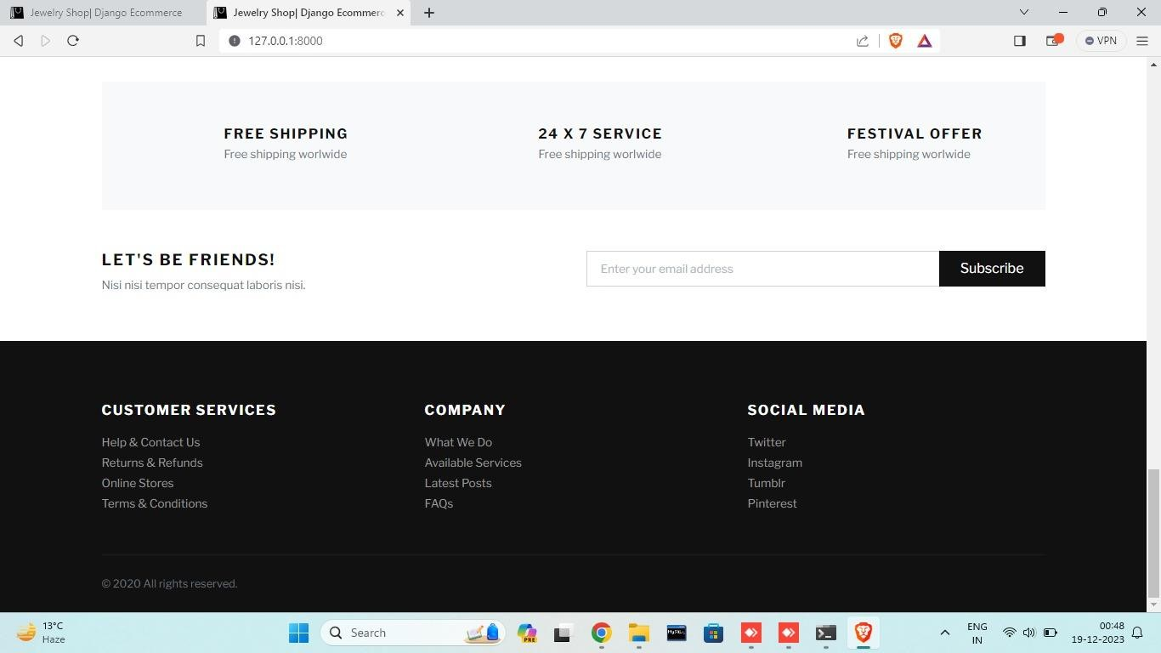

Figure 8

## Login Module

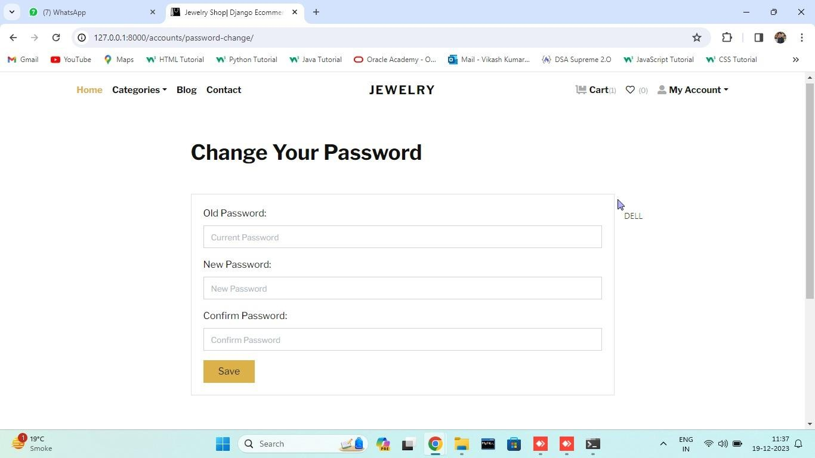

Figure 9

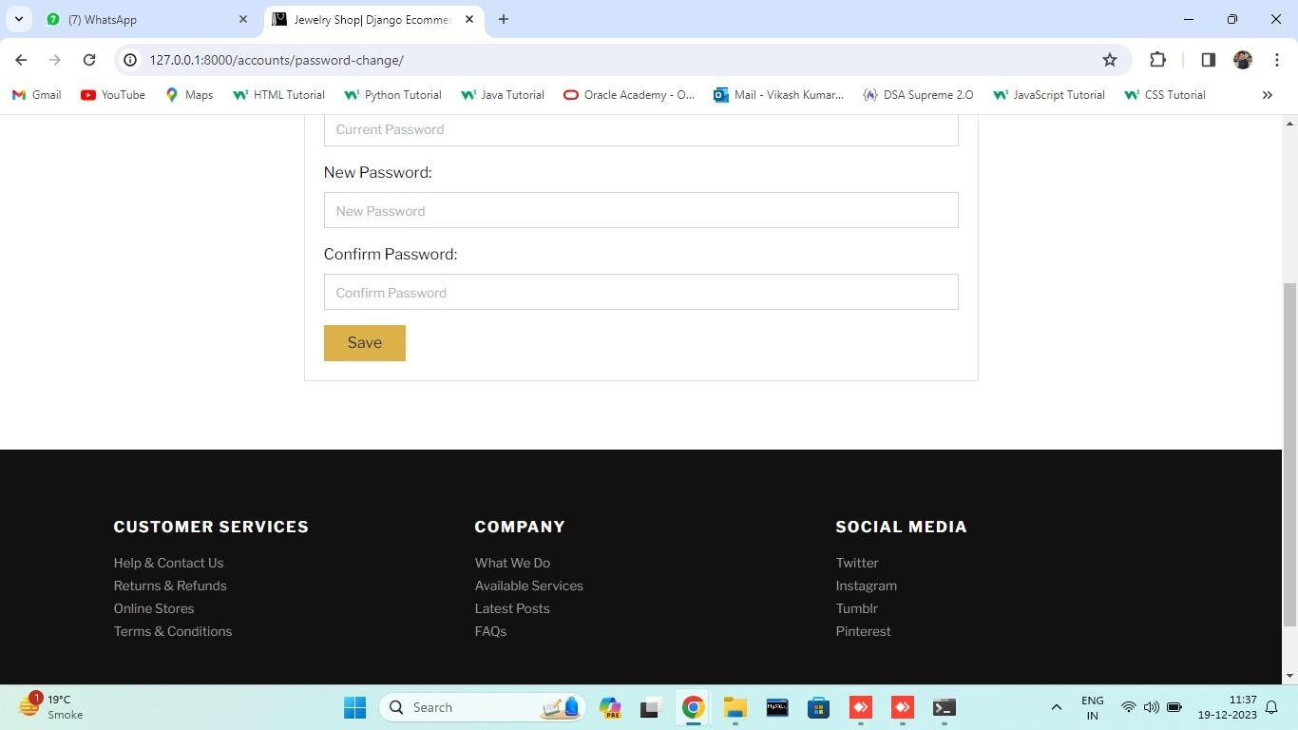

Figure 10

## Account Page

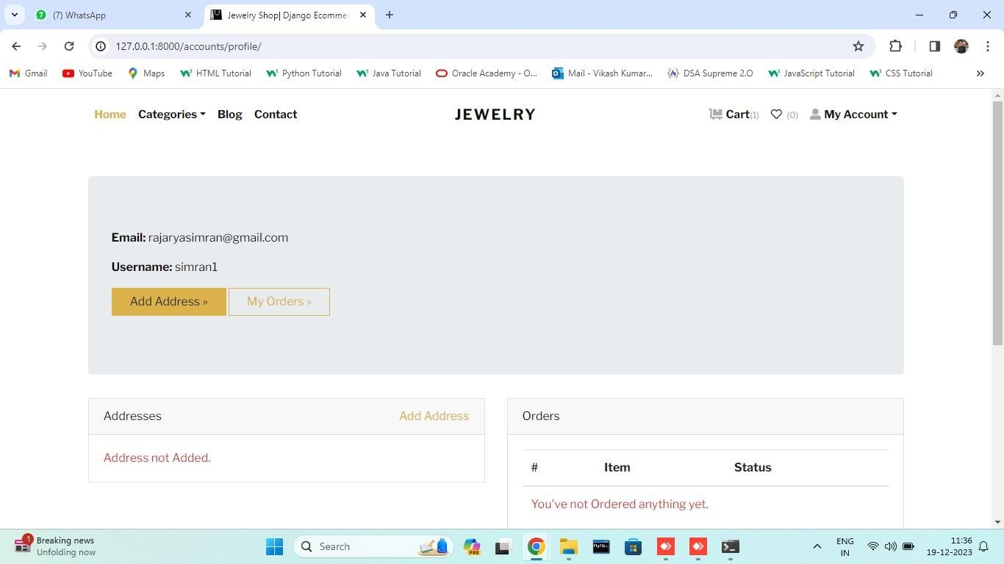

Figure 11

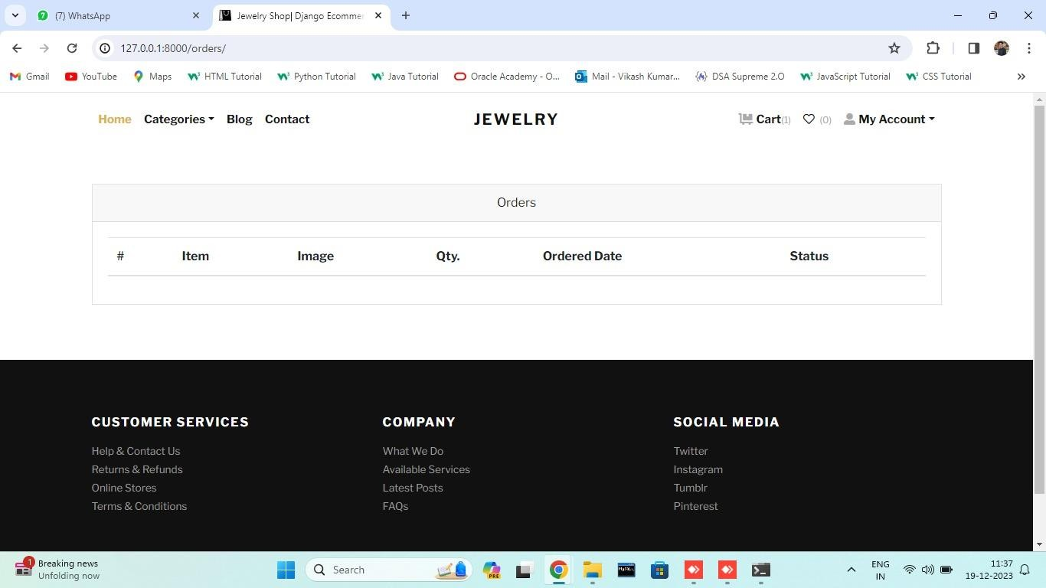

Figure 12

## Categories Page

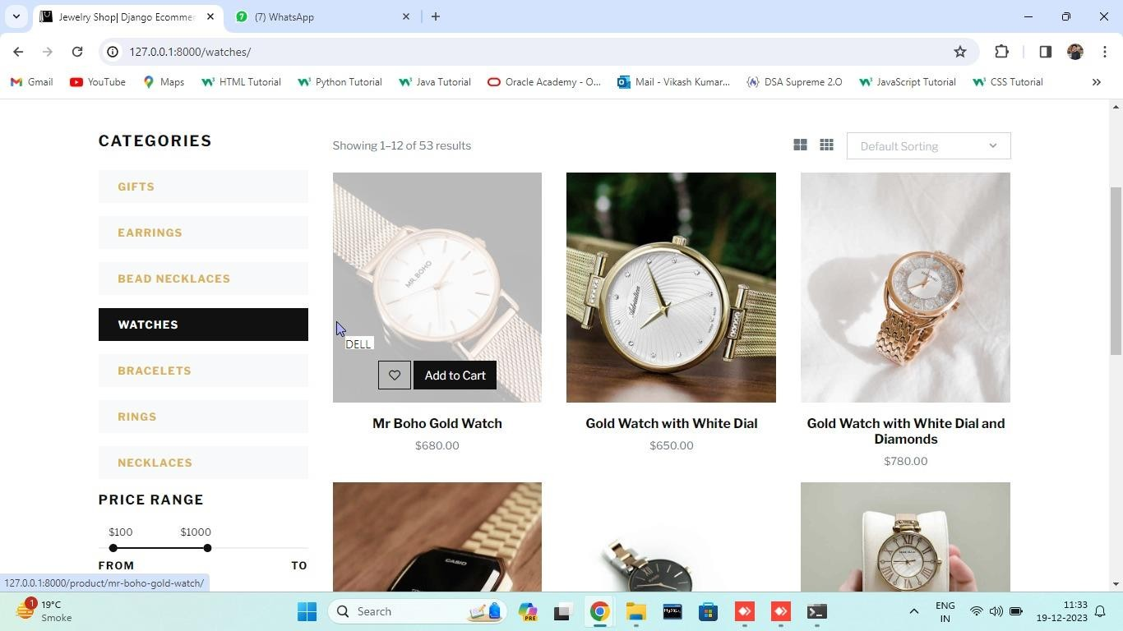

Figure 13

# TESTING METHODLOGY :

## Requirement Analysis

* + - Understand and document the functional and non-functional requirements of your e-commerce system.
    - Identify critical functionalities such as user registration, product browsing, shopping cart, checkout, payment processing, and order management.

## Test Planning

* + - Develop a comprehensive test plan outlining the testing strategy, scope, objectives, resources, schedule, and deliverables.
    - Identify test scenarios, test cases, and test data.

## Functional testing

### User Interface Testing

* Verify that all user interfaces (web pages, mobile app screens) are visually appealing, consistent, and user-friendly.
* Validate navigation, links, buttons, and overall layout

### User Registration and Authentication

* Test user registration and login functionalities
* Check for password security, account recovery, and session management.

### Product Management

* Verify that products are displayed correctly with accurate information.
* Test product search, filtering, and sorting options.

### Shopping Cart

* Ensure items are added to the cart correctly.
* Verify the calculation of totals, taxes, and shipping charges.

### Checkout Process

* Test the entire checkout process, including shipping address entry, payment options, and order confirmation.
* Validate the handling of discounts and promotions.

### Security Testing

* + **Data Encryption**
* Verify that sensitive information (user credentials, payment details) is encrypted during transmission.

### Payment Gateway Security

* Test the security of the payment gateway.
* Ensure that payment information is processed securely.

### Authentication and Authorization

* Verify that only authorized users can access certain functionalities.
* Test session management and logout functionalities.

## Performance Testing

### Load Testing

* Simulate realistic user loads to ensure the system can handle peak traffic.
* Identify and eliminate performance bottlenecks.

### Response Time

* Measure and optimize response times for critical actions (e.g., product search, checkout).

### Scalibilty

* Verify that the system can scale to handle an increased number of users and transactions.

### Compatiblity Testing

* Verify that the system can scale to handle an increased number of users and transactions.

### Database Testing

* Validate data integrity, accuracy, and consistency in the database.
* Check for proper indexing and optimization..

### Error Handling Recovery

* Test how the system handles errors, edge cases, and exceptions.
* Verify that appropriate error messages are displayed to users.

### Regression Testing

* Perform regression testing after each code change to ensure that existing functionalities are not affected.

### User Acceptance Testing

* Involve actual users to validate that the system meets their expectations.
* Gather feedback on any additional improvements.

### Documentation

* Ensure that all testing activities are well-documented, including test cases, test results, and any issues found.

By following this testing methodology, we can systematically ensure the quality and reliability of our e-commerce minor project. Keep in mind that testing is an iterative process, and continuous improvement should be part of the development lifecycle.

# FUTURE SCOPE

The future scope of the e-commerce website may involve several different areas of development and growth, such as:

1. Mobile Application: Develop a mobile application for the commerce platform to cater to the growing number of mobile users. This will provide a seamless and optimized shopping experience, leveraging mobile-specific features such as push notifications, mobile payments, and augmented reality for virtual try-on experiences.
2. Personalized Recommendations: Implement advanced recommendation algorithms to offer personalized product recommendations based on user preferences, browsing history, purchase patterns, and demographic information. This can enhance the customer experience and increase conversion rates.
3. Virtual Reality (VR) and Augmented Reality (AR): Integrate VR and AR technologies to allow customers to virtually try on jewelry pieces and visualize how they would look before making a purchase. This immersive experience can increase customer engagement and confidence in their buying decisions.
4. Social Media Integration: Enable social media integration to allow customers to share their favorite products, create wish lists, and receive recommendations from their social networks. This can boost brand visibility, attract new customers, and facilitate social proof.
5. Blockchain Technology: Explore the use of blockchain technology to ensure the traceability and authenticity of products. Implementing blockchain-based solutions can enhance transparency, reduce fraud, and provide customers with verifiable information about the origin and certification of the jewelry they purchase.
6. Advanced Analytics and Insights: Leverage big data analytics to gain valuable insights into customer behavior, market trends, and product performance. This can help optimize inventory management, pricing strategies, marketing campaigns, and overall business decision- making.
7. Enhanced Security Measures: Stay ahead of evolving cybersecurity threats by implementing advanced security measures such as multi- factor authentication, encryption, and fraud detection systems. Ensuring the security of customer information and transactions is crucial to maintain trust and protect against potential data breaches.

# CONCLUSION

In conclusion, our minor project, the e-commerce web application, represents a significant milestone in the digital transformation of the industry. Through meticulous design, robust functionality, and a customer-centric approach, we have created a platform that offers a seamless and delightful shopping experience for jewelry enthusiasts. With a diverse collection of exquisite jewelry, personalized customization options, secure payment processes, and efficient shipping services, our web application aims to redefine the way people discover, explore, and purchase jewelry online. Looking ahead, we envision exciting possibilities for future growth, including mobile application development, integration of advanced technologies like virtual reality and augmented reality, and international expansion. By staying at the forefront of innovation and continuously enhancing our platform, we are dedicated to providing an exceptional and trustworthy online jewelry shopping experience. Our major project stands as a testament to our commitment to excellence, customer satisfaction, and the advancement of the e-commerce jewelry industry. “On-Line Shopping” is a web-based project which is made for remote-shopping or shopping through Internet. As the technology is being advanced the way of life is changing accordance. Now a day’s we can place the order for anything from our home. There is no need to go the shop of the things we want. The order can be placed online through Internet. The payment, the confirmation of purchasing; we can do everything we want.

# REFERENCES

1. <http://www.ecom.cmu.edu/resources/elibrary/eclgloss.shtml>.
2. <http://ecommerce.internet.com/resources/library/paysolutions>.
3. [http://www.oregoninnovation.org/pressroom/glossary.a-c.html.](http://www.oregoninnovation.org/pressroom/glossary.a-c.html)
4. <http://www2.uta.edu/ecomm/resources/glossaryComplete.asp>.
5. <https://github.com/topics/ecommerce-website>
6. https://elogic.co/blog/ecommerce-website-development-project-plan- a-guide-to-your-project-preparation

.

# 